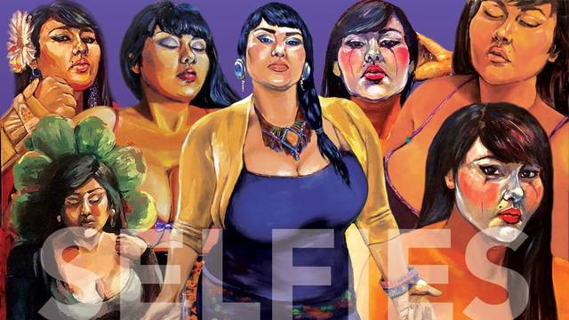
“The Art of the Self-Portrait”

Thursday, March 23, 6:30-8:30 pm Fireside Room, BC Main Campus
=========

Los Angeles-based artist, Crystal Galindo, whose artistry emphasizes the Chicana experience & body-type exploration, focusing on "celebrating diversity and power in cultura", will present techniques & theories related to the art of the self-portrait.

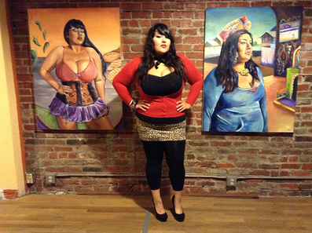
“Inspired by the lack of representation of women of color in the media, Crystal’s work spotlights Xicanas in a positive, realistic light. Her work analyzes the many facets of Chicana women, celebrating the diversity and power in cultura. Crystal’s current series is a reflection of a change in paradigm, displaying a visually vast array of friends, family and fellow artistas, who boldly confront their viewer amid imaginative design and Mesoamerican iconography. The use of larger than life portraits amid bold colors creates a presence that cannot be ignored.”
For more information contact Tina Mendoza at: tina.mendoza@bakersfieldcollege.edu

